**PREDICTING FUTURE EMISSIONS FROM METAL MINING IN NIGERIA BASED ON CLEAN ENERGY MINERALS PROSPECT**

**BY**

**MARIAM ALAKE KASALI**

**(2487996)**

**A REPORT OF AN INTERNSHIP CENTERED AROUND MINERAL EXPLORATION IN NIGERIA WITH XCALIBUR MULTIPHYSICS THROUGH THE PAGODA PROJECTS SUBMITTED TO THE CENTRE FOR ENERGY, PETROLEUM AND MINERAL LAW & POLICY (CEPMLP), SCHOOL OF SOCIAL SCIENCE, UNIVERSITY OF DUNDEE**

**OCTOBER 2022**



Approval Form for Internship

**To be completed by student and signed by supervisor**

|  |  |
| --- | --- |
| **FULL NAME:** | MARIAM ALAKE KASALI |
| **MATRICULATION NUMBER:** | 2487996 |
| **NAME OF HOST INSTITUTION:** | UNIVERSITY OF DUNDEE |
| **DEPARTMENT WITHIN INSTITUTION:** | CEPMLP |

**Full details of supervisor within institution**

|  |  |
| --- | --- |
| **NAME:** | Adriana Mantilla-Pimiento |
| **DEPARTMENT:** | Technical Department |
| **POSITION:** | Senior Geophysical Advisor |
| **POSTAL ADDRESS:** | Avda, Partenon 10, 2nd floor, 28042, Madrid, Spain. |
| **PHONE:** | +34912308191  +34616524309 |
| **EMAIL:** | [adriana.mantilla@xcaliburmp.com](mailto:adriana.mantilla@xcaliburmp.com) |

Details of Internship:

|  |  |  |  |
| --- | --- | --- | --- |
| **EXPECTED START DATE:** | 23rd MAY 2022 | **EXPECTED DURATION:** | 2 Months |

You should attach an explanation of your objectives and of your expected duties and tasks. This should be drawn up in discussion with your supervisor in the host institution. It should be one to two pages in length and forms the most important part of the approval process. You should also attach a letter or an e-mail from the supervisor of the institution offering the internship confirming the offer.

**Internship Objectives**

Learn to build a GIS data base integrating geological and geophysical maps.

Learn the basis of the geological interpretation and mapping of radiometric and magnetic data, using specialized software.

Learn how new and environment-friendly technologies (aircraft) are used to acquire geophysical data

Develop and strength geosciences software and technical report writing skills.

**Duties & Tasks**

Support the project staff on the data compilation at the NGSA remotely and onsite.

Participate and contribute on the discussion related to the geological interpretation of the geophysical maps and sustainable future mining of the study area

Participate in meetings with the technical staff and prepare summary notes.

Support the technical reports preparation

Number of CEPMLP credits: 20 40 (circle the appropriate one)

### **Information Relating to Health, Safety and Welfare**

Please will you answer the following questions. This will allow both you and staff at CEPMLP to judge the risks that you may face when undertaking your internship.

1. Have you visited the country of your internship before?

Yes No

If yes, please explain when and under what circumstances.

The internship will take place online and in my home country.

If no, please explain what steps you have taken to familiarise yourself with the country and the challenges and risks you may face working and living there

1. Have you visited the city/town of your internship before?

Yes No

If yes, please explain when and under what circumstances

* Official visit with family

If no, please explain what steps you have taken to familiarise yourself with the city town and the challenges and risks you may face working and living there

1. If your internship is taking place outside the UK or your home country, have you arranged personal insurance?

Yes No Not applicable

1. If you have any special needs or disabilities, have you informed the host institution?

Yes No Not applicable

5. Have you already arranged a place to live during your internship?

Yes No

If yes, where?

If no, how do you plan to do this?

* This will be arranged by the internship host company.

If you have any uncertainties concerning your internship, please discuss them with your supervisor.

Please read and sign the following statement. After having discussed your Internship arrangements with your supervisor, please ask them to sign below and then pass your Internship Approval Form to Alison Anderson.

“(1) the University is not responsible for arranging electives, and it takes no legal responsibility for any liability, whether negligent or otherwise, for any loss, damage (financial or otherwise), or for ill-health or death, so far as such exclusions are permissible by law;

(2) the student is responsible for making all the arrangements for the elective, including destination, work, accommodation, travel, food, etc.;

(3) the student confirms that he/she has already arranged appropriate medical, travel and life insurance for the elective and accepts that it is the responsibility of each student to arrange this;

(4) the student accepts that the laws of other countries differ from those in the UK, and students on overseas electives should familiarise themselves with these and exercise considerable care accordingly.

(5) the student acknowledges that she/he is aware of the appropriate emergency contact details for University and for the British Embassy/Consulate or equivalent, and of local health service provision

(6) the student acknowledges that he/she has been invited to disclose any disability which he/she wishes, and has informed the University of any disability to the extent that the individual wishes to, for the purposes stated, and confirms that he/she has discussed all the arrangements made and is happy with them.” (University Memorandum, 15 January 2002, AFP/KFS/H/LAW/CIRCULAR2.DOC)

Student’s signature:



Date: 24th May 2022

CEPMLP supervisor’s approval

Name: Dr Ana Bastida………………………………………………………………………………………………………

Signature: Ana Bastida

Date: ………………………………………………………………………………………………………



### **Internship Supervisor’s Report Form**

**To be completed by Internship Supervisor**

Full name of student: Mariam Kasali

Name of Institution providing Internship: Xcalibur Multiphysics

Address of Institution: Avenida Partenón, 10, 2nd Floor, 28042 Madrid (Spain)

General nature of business of this institution: Airborne Geophysical Services

Details of intern’s supervisor within the institution

Name of supervisor: Adriana Mantilla Pimiento

Position of supervisor Senior Geophysical Advisor

Telephone number: +34 912 308 191

Was the nature of your supervision: General oversight

Detailed day-to day supervision

Details of internship

Time period: From: 23rd May 2022

To: 15th July 2022

Number of weeks worked (exclude holidays): Eight weeks

Number of days per week worked: Five days

Department (s) in which intern worked: Technical Department

General nature of work undertaken: Data compilation and report writing for a world bank project in Nigeria.

Specific projects undertaken or documents prepared:

Skills required of the student in order to undertake this work: Report writing, GIS software skill, Microsoft packages skill, office ethics skill, communication skill and minutes taking.

**Assessment of Student**

Please tick the appropriate boxes in the table below

|  |  |  |  |
| --- | --- | --- | --- |
|  | Unsatisfactory | Satisfactory | More than satisfactory |
| Intellectual capacity |  |  | X |
| Willingness to learn new skills |  |  | X |
| Ability to work with other people |  |  | X |
| Professionalism |  |  | X |
| Quantity of work |  |  | X |
| Quality of work output |  |  | X |
| Overall assessment |  |  | X |

Any additional comments on the student’s performance:

**Value to your Institution**

Has this internship proved valuable to your institution?

Yes! great support on a special project.

Would your institution be prepared to offer further internships to CEPMLP students in the future?

YES

If “yes” please provide information on the type of student you might prefer. If “no,” please explain.

Signed: Adriana Mantilla Pimiento

Date: 15th July 2022

Thank you for providing our student with the opportunity to undertake this internship and for completing this form.

**Confidentiality Clause**

I agree that the Internship Report prepared by the student, based on the Internship Programme undertaken with this Company, may be lodged in the CEPMLP Information Services (Library), thus making it available to others to read:

Signed: …………………………………………………………………………………………………………………………………...

I do not wish the student’s Internship Report, based on the Internship Programme undertaken with this Company, to be available to others to read, due to the confidential nature of the information contained within the Report:

Signed: Adriana Mantilla Pimiento

1. The assessment of the work undertaken should be based mainly on the report from the supervisor within the institution (which should be attached to this mark sheet) and to a lesser extent on the student’s own internship report.
2. Quantity of work done. To what extent does the institutional supervisor’s report indicate that the student worked hard?
3. Quality of work done. To what extent does the institutional supervisor’s report indicate that the student achieved what was expected and agreed, and showed interest, creativity, dedication, and inter-personal skills in carrying out the required tasks?
4. Description of nature of work. How well does the report describe what the student actually did?
5. Appreciation of practical relevance. How well does the report show that the student appreciated the practical relevance of the internship?
6. Integration with previous learning at CEPMLP. How well does the report show that the student integrated their academic learning at CEPMLP with the practical experience of the internship?
7. Development of new ideas and approaches. To what extent does the report show that the student has used the internship to develop new ideas, new understanding, or new approaches to the subject of the internship?
8. Overall rating: this should be based on the integration of all the above considerations. The examiner is allowed some scope to decide an overall rating, but should recognise that in most cases (a) to gain an overall Distinction, students should achieve a distinction in all or nearly all the categories; and (b) a fail in any one or more of the categories marked by a * may deserve an overall fail.

CERTIFICATE OF INTERNSHIP

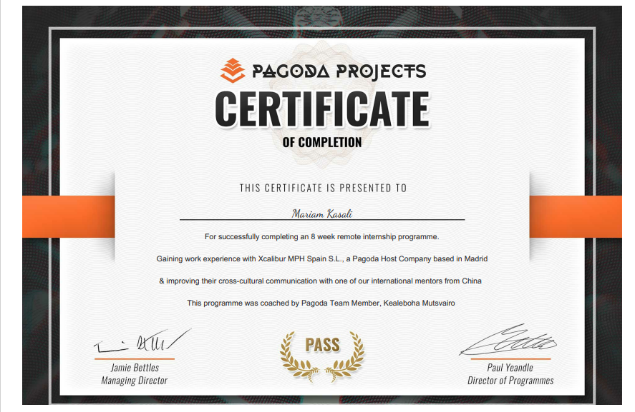

ACKNOWLEDGEMENT

Firstly, I would like to thank God almighty for his protection and guidance towards completing my internship program and report despite the various challenges I have encountered.

My sincere appreciation also goes to my course adviser, Dr Ana Bastida and my internship Supervisor, Dr Simon Cook, for their guidance and feedback towards completing a solid academic internship report. It was very challenging for me at the beginning, especially on how to structure my writing, but with their help, I could give a good report and complete it on time.

With a grateful heart, I am thankful to my host company, Xcalibur Multiphysics, for allowing me to do my internship program in their organisation. I want to thank my supervisor Adriana Mantilla head of the technical department and Geophysical advisor, for her support and always putting me first during the internship; she organised my training and learning to help with my internship report.

Finally, I want to thank my husband, Kazeem Adetayo Oduyebo, my parents Dr and Mrs Kasali and my siblings for their encouragement and support in making sure I had all that is required to write a good report and complete my MSc programme in flying colours.

TABLE OF CONTENT

**TITTLE PAGE**

TITTLE PAGE....................................................................................................... 1

APPROVAL FORM FOR INTERNSHIP................................................................... 2

CERTIFICATE OF INTERNSHIP............................................................................. 10

ACKNOWLEGDEMENTS...................................................................................... 11

TABLE OF CONTENTS ......................................................................................... 12

LIST OF FIGURES.................................................................................................. 14

LIST OF TABLES................................................................................................... 15

1.0 CHAPTER ONE INTRODUCTION …................................................................ 16

1.1COMPANY INFORMATION........................................................................ 16

1.1.1 ABOUT PAGODA PROJECTS............................................................. 16

1.1.2 ABOUT XCALIBUR MULTIPHYSICS.................................................... 16

1.2 LOCATION AND MODE OF INTERNSHIP.................................................... 17

1.3 SCHEDULE OF INTERNSHIP........................................................................ 18

1.4 BACKGROUND OF THE STUDY................................................................... 19

1.5 STATEMENT OF THE PROBLEM................................................................. 21

1.6 AIM OF THE STUDY................................................................................... 22

1.7 OBJECTIVES OF THE STUDY....................................................................... 22

2.0 CHAPTER TWO: INTERNSHIP DESCRIPTION................................................... 23

2.1 MY JOB...................................................................................................... 23

2.2 MAJOR OBJECTIVES AND MY DUTIES AS AN INTERN................................ 24

2.3 OVERVIEW OF OVERALL EXPERIENCE....................................................... 25

3.0 CHAPTER THREE: CLIMATE-SMART MINING/ THE NIGERIA PROJECT........... 26

3.1 METHODOLOGY........................................................................................ 26

3.1.1 AIRBORNE GEOPHYSICAL SURVEY.................................................... 26

3.1.2 LITERATURE REVIEWS....................................................................... 26

3.2 LITERATURE REVIEWS ON RELEVANT TOPICS........................................... 27

3.2.1 ESTIMATES OF EMISSIONS ASSOCIATED WITH MINERALS MINING. 27

3.2.2 GREENHOUSE GAS EMISSIONS IN NIGERIA...................................... 29

3.2.3 SOLID MINERAL DISCOVERY IN NIGERIA.......................................... 30

3.3 DATA ANALYSIS......................................................................................... 31

3.4 KEY FINDINGS............................................................................................ 32

3.5 POTENTIAL CARBON EMISSIONS IN NIGERIA............................................ 32

4.0 CHAPTER FOUR.............................................................................................. 33

4.1 RECOMMENDATION................................................................................... 33

4.2 LIMITATIONS............................................................................................... 34

5.0 CHAPTER FIVE: CONCLUSION.......................................................................... 35

5.1 CONCLUSION............................................................................................... 35

6.0 REFERENCE...................................................................................................... 36

List of FIGURES

Figure 1 shows map of Spain............................................................................................ 17

Figure 2 shows map of Nigeria showing the states in Nigeria and the capital Abuja........ 18

Figure 3 shows how most countries are investing in energy transition for a Net zero...... 20

Figure 4 shows base metal ore mine emitting lower tonnes of CO2 gas than the coal mine.... 20

Figure 5 shows minerals required for clean energy transition................................................ 21

Figure 6 shows map of Nigeria showing the geophysical survey area and mineral data coverage within the western block..................................................................................................... 24

Figure 7 shows carbon footprint of global Zinc production................................................ 28

Figure 8 shows energy required in extracting Cobalt in Cumulative energy demand.......... 29

Figure 9 shows the graph of Carbon emissions released during the mining of various green minerals................................................................................................................................ 32

LIST OF TABLES

Table 1 shows the different minerals required for green energy transitions and the amount of CO2 emitted during their mining extraction phase.............................................................................. 31

CHAPTER 0NE- INTRODUCTION

1.1 COMPANY INFORMATION

1.1.1 About pagoda projects:

The pagoda projects company, founded in 2007 by Jamie Bettles, is currently located in Manchester, United Kingdom; the company consist of a team of innovative and diverse individuals collaborating with universities and governmental organisations to bring work experience opportunities to graduates and students globally. The company's core value is building a four working days structure and impacting the environment sustainably. As exemplified on their website and in my experience as a beneficiary of their internship awards, they provide an avenue for everyone to be a winner in their various fields through internship placement, cultural mentorship programs, mandatory feedback and get-together.

I first came across the pagoda internship program on my university website in January 2022, after which a teams meeting was held between a representative from the pagoda team Mr Ali Hashemi, the university of Dundee staff and interested students from the university. Mr Ali Hashemi explained in detail what the pagoda internship entails and the procedures for applying for the internship program; in his explanation, pagoda projects often act as an intermediary between individuals (students and graduates) and organisations towards connecting them with their best fit in terms of educational background, experience and companies’ content.

A video application was required for the pagoda internship; the University of Dundee sponsored the training. I made a video application in which I talked about my background in Applied Geophysics, my current course of study, MSc sustainability: Climate change and the green economy and my overall experience over the years. I made my video and CV submission on 2nd February 2022 and got a confirmation of an offer of a place in the program by 8th March 2022.

Furthermore, the pagoda team sent out my CV and video to relevant organisations that match my future ambition and career goals; after a few interviews, I was accepted for an internship with Xcalibur Multiphysics; which happened to be working on a geophysical exploration project in Nigeria.

1.1.2 About Xcalibur Multiphysics:

Xcalibur Multiphysics is a geophysical solution company involved in airborne and marine geophysical data acquisition, processing, interpretation and management. They use advanced, technologically innovative equipment to sustainably discover natural resources and deliver data to clients in a well-detailed and tailored manner. Xcalibur Multiphysics have a team of highly skilled and experienced personnel who contribute to its global presence and operational excellence.

Since 1982, the company has been involved in over 1000 projects, mainly in mineral exploration, Oil and Gas, geothermal and groundwater mapping. They have worked with the public and private sectors, including primary and upcoming organisations. Xcalibur Multiphysics have branches in 13 countries, such as Asia, South Africa, Canada, Spain etc., and their head branch is in Madrid, Spain. They specialise in Gravity, Gravity gradiometry Falcon, radiometric, Geographical information systems, radiometric, electromagnetics and magnetic surveys using sophisticated and environmentally friendly equipment. Xcalibur Multiphysics boost of over 20 owned aircraft, 85 geophysical systems and 250 teams of competent employees.

The company’s core value is in building a safe working environment, efficient costing (decentralised operation and investment in personal aircraft and equipment), prioritising sustainability measures, innovative technology (such as R&D investment and use of technologies like TEMPEST AEM, Heli FALCON AGG, FALCON AGG, HELITEM AEM AND RESOLVE AEM), transparency, accountability and quality/excellent operations (quality resolution of the earth subsurface with the use of standard equipment, ability to fly at low altitude, competent workers such as pilots, geophysicists, geologist, operators and technicians and incorporation of clients idea in decision making). All of these are what I experienced during my internship program with them.

Furthermore, in August 2021, Xcalibur Multiphysics established a non-profitable foundation in Spain to help the needy achieve primary education and support people interested in sports. They often collaborate with other foundations, governmental organisations and local authorities of the countries where they have a presence to achieve set goals.

1.2 LOCATION AND MODE OF INTERNSHIP

The internship programme was held in a combined online and physical format. The program started as an online internship in which I often communicated through emails and video conferencing with my supervisor and other company employees. Later in training, I could physically work with my supervisor in my home country, Nigeria.

The internship location was in Madrid, Spain and Abuja, Nigeria. According to Briney (2021), Spain is a European country located in the southwestern part of Europe, part of her coastlines falls within the Atlantic Ocean and the Mediterranean Sea. Also, Spain has an overall population of about 50 million people, with Madrid as its largest city and capital. The language spoken in Spain is called Spanish.

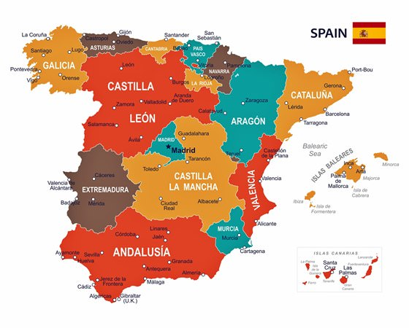

Figure 1 shows map of Spain (orangesmile.com)

On the other hand, the project I was involved in was being carried out in Nigeria. According to the Nigeria High Commission, Nigeria is in West Africa with a land mass of 910,770 Km2 and a population of about 140 million people. The capital of Nigeria is Abuja, and four major languages (English, Hausa, Yoruba and Ibo) are spoken in the country.

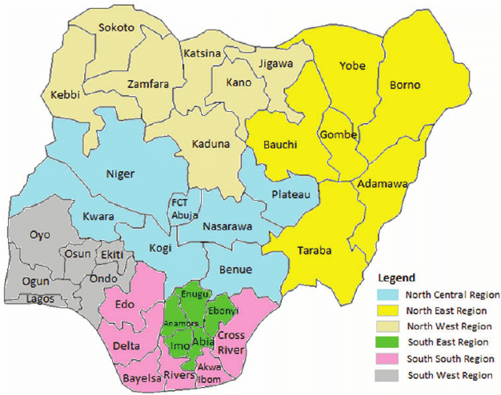

#### Figure 2 shows map of Nigeria showing the states in Nigeria and the capital Abuja (Ezra Gayawan, 2014)

1.3 SCHEDULE OF INTERNSHIP

As proven in my university internship approval letter, the internship program was scheduled for two months by Pagoda projects, and it ran from the 23rd of May 2022 to the 15th of July 2022. There was a total of eight weeks in which different activities were scheduled for me by Pagoda projects outside of my working hours. I spend the first six weeks working remotely and the last two weeks in Nigeria with my supervisor for data compilation from the clients on a world bank mineral exploration geophysical survey project in the country.

Also, a culture mentoring session was scheduled every Saturday during the internship. A report of the weekly activities I have been involved in was usually submitted every Friday via the pagoda portal.

1.4 BACKGROUND OF THE STUDY

National Geographic explained that there had been a continuous increase in the global mean surface temperature above 0.6-degree Celsius since 1906, which is causing the earth’s planet to warm up, resulting in physical effects like glacier meltdown, animal migration and shift in rainfall patterns. Similarly, the NOAA.GOV affirmed that climate change was more than just a rise in surface temperature but a condition that is accompanied by many changes to the environment and the way human beings live and survive. To that end, some of the impacts of climate change, as mentioned by NOAA.GOV, includes a rise in sea level, severe drought and flooding in many parts of the world, spread of diseases and sickness, poverty, exposure to socioeconomic inequity as the vulnerable communities are most prone to climate hazards. In addition, climate change has been proven to have a psychological effect on the mental state of the people traumatised by its accompanying environmental hazards leading to mental disorders and post-traumatic stress transfer to the future generation ( Cianconi et al., 2020). Furthermore, A write-up by Jeff Tollefson, 2022 on the report given by IPCC also mentioned the high mortality rate caused by climate change events on the people, especially vulnerable groups. The work of Calleja-Anguis et al., 2021 also backed this up, that there is a high rate of mortality due to climate change impacting extreme cold or hot weather conditions, some vulnerable groups with co-morbid cardiovascular or respiratory diseases are often harshly affected and which could lead to their death.

Referring to the views of Thompson (2010) about the causes of climate change, he enumerated two significant reasons to be natural and manmade. He mentioned that natural forces such as volcanic eruptions, which have led to the release of environmentally damaging gases and El-Nino conditions in the Pacific Ocean, contribute to climate change. He further stated that the occurrence of climate change for the past 100 years had been majorly due to human activities such as releasing greenhouse gases into the atmosphere through deforestation, mining, production of oil and gas, burning of household waste, animal rearing etc.

In the event of high carbon emissions and climate change, White et al. (2022) explain how the primary aim of most countries around the world is to decarbonise the economy drastically and how much they are willing to invest in the transition process. These can be seen in figure 3 below as 1 trillion USD to 2 trillion USD is expected to be spent yearly; these amounts can also increase with time. Most countries’ primary focus is to reduce the use of fossil fuels, increase electricity networks and invest more in renewables and energy efficiency.

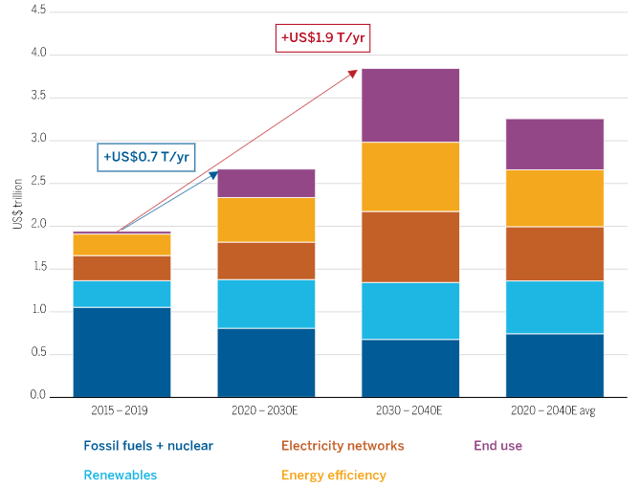

Figure 3 shows how most countries are investing in energy transition for a Net zero (IEA.org, 2021)

However, most countries have not paid much attention to the damages caused by mineral extractions through heavy mining, and according to Norgate et al., 2010 as stated in Ruttinger et al. (2016), the mining sector is one of the significant producers of greenhouse gases due its highly intensive energy usage. In addition, MCA (2015) mentioned that one of the considerable extractives of mining is coal, a fossil fuel source and a significant producer of carbon. Also, they said further that coal does not produce carbon emissions when it is burnt alone but also during the process of mining it. Likewise, Ruttinger et al. (2016) further affirmed that no two mining are the same in terms of carbon emissions depending upon the mineral being extracted and the process of extracting; figure 4 shows the mining of two different minerals and the tonnes of carbon emissions that was released in the process.

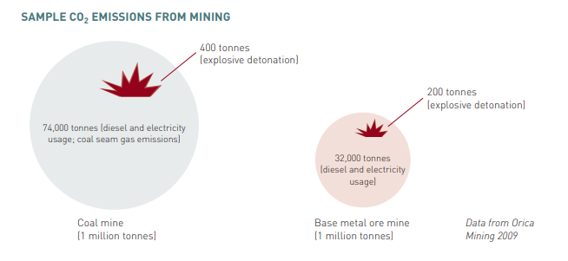

Figure 4 shows base metal ore mine emitting lower tonnes of CO2 gas than the coal mine. (Ruttinger et al., 2016)

1.5 STATEMENT OF THE PROBLEM

Fifty billion tonnes of greenhouse gases are emitted yearly worldwide (Ritchie et al., 2020). Dellevingne et al. (2020), said mining accounts for about 7% of the global greenhouse gas emission. The world is currently in a race to meet the net zero target, thereby putting pressure on the mining industry to source raw materials for clean energy and technologies (Mckingsey&Company, 2022). However, the International Energy Agency IEA (2021) suggests balancing the emission from minerals production despite the high demand for the minerals. Therefore, due to the way various countries are sourcing raw minerals, there is a need to predict the possibility of increased emissions from mining and methods to reduce emissions at every level of mining activity, starting from mineral prospecting and the actual mining activities. Figure 5 below shows a list of raw minerals required for the energy transition.

#### Figure 5 shows minerals required for clean energy transition (IEA,2021)

1.6 AIM OF THE STUDY

Although the internship program is a compulsory module for my university program and a means for me to acquire work experience in my field of study, this report aims at predicting future emissions from the mining of green minerals discovered so far in Nigeria based on my first-hand experience working with Xcalibur Multiphysics on mineral prospecting in Nigeria using airborne geophysical survey methods.

1.7 OBJECTIVES OF THE STUDY

This report is centred on past literature on emissions associated with different mineral extractions. It also explores the future contribution of the Nigerian economy to global greenhouse gas emissions in mineral mining. In addition, the report touches on the area of mineral prospecting in Nigeria. Further, it discusses the type of minerals discovered in Nigeria so far and if they form a significant part of the raw material required for green energy in this trying time of the pressure to meet net-zero worldwide. Finally, the estimation of the tonnes of future emissions from mining these minerals will be discussed.

CHAPTER TWO- INTERNSHIP DESCRIPTION

2.1 MY JOB

My host company Xcalibur Multiphysics offered me an internship role in the geophysical department, where I was introduced to my supervisor, Adriana Mantilla-Pimiento (Senior Geophysicist) and other members of the company, such as Carlos Velando (Senior Geologist), Fernando Mondelo (Senior Geophysicist and Alejandra Gonzalez (Administrative assistant). The geophysical department oversees projects involving geophysical data acquisition, processing and analysis using sophisticated technologies and software. One major software used in the geophysics department and which training was set up for me via the SEEQUENT platform Is the oasis Montag software used for most geophysical data processing, other software used are GIS and surfer. My internship started as an online job as I was working from home, and I had a few papers sent to me to read and review to help me familiarise myself with the project the team was working on in Nigeria. I was also working on my online training on Geostudio and learning about different kinds of analysis and geometry used for processing different geophysical scenarios while attending meetings with the clients in Nigeria and taking minutes of the sessions. The Nigeria project is based on mineral prospecting and was funded by the world bank in collaboration with the Federal government of Nigeria, the Federal ministry of mines and steel development and the Mineral sector for economic diversification project; I often had discussions with my supervisor on the sustainable extraction of green minerals if eventually they are found in abundance within Nigeria given survey area. I was also sent the scope of work and timeline for the geophysical airborne magnetic and radiometric survey deliverables. At the end of every week, I often did a weekly check-in on the pagoda project platform, which I put in my internship journal, I also had a cultural mentor from China who I met via video conferencing weekly in other to introduce me to the Chinese culture, and after our meetings, I always put in my cultural journal on the pagoda platform. During my internship program, I often attended online events which were hosted by experienced personnel in the job industry, topics such as working remotely, making the most out of an internship program, time management, working in a diverse environment, soft skills and employability skills development were discussed at the events; I also completed training on digital competency, employability skills, intercultural fluency and workplace basics after which I was awarded certificates of completion. Towards the end of the internship program, I was required to meet with the clients at the Nigeria Geological Survey Agency office in Abuja together with my supervisor Adriana for a data compilation stage of the project where I had a first-hand experience working alongside professionals in the field and learnt how to communicate effectively with clients. I could also use my Microsoft package skills to carry out duties assigned to me by my supervisor.

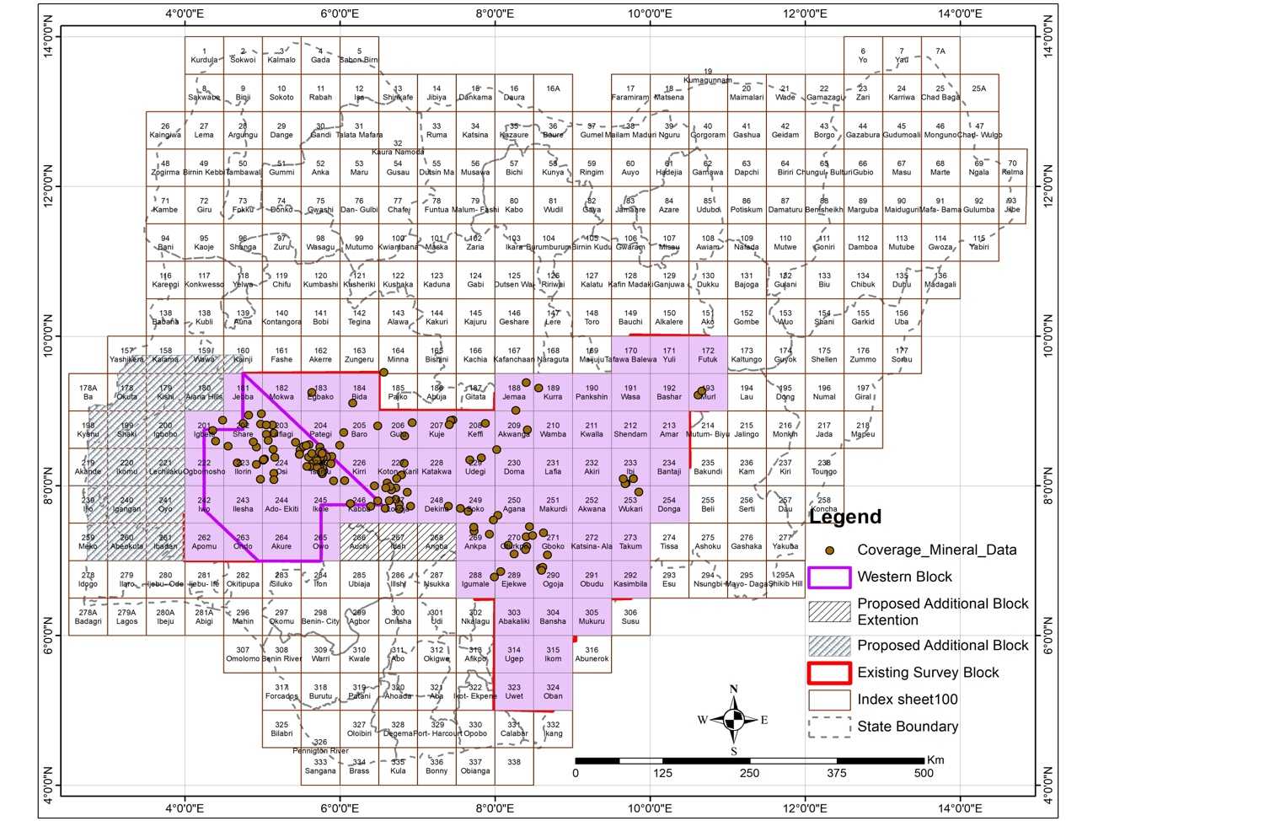

Figure 6 shows map of Nigeria showing the geophysical survey area and mineral data coverage within the western block.

2.2 MAJOR OBJECTIVES AND MY DUTIES AS AN INTERN

As an intern in the geophysics department with Xcalibur multiphysics, coupled with my current MSc., Program in Sustainability, climate change and the green economy and my background in Geophysics; this means that I had to get training on the current software used by my host company to carry out geophysical processing and interpretation. I learnt how to use the GIS software to build a database using previous geological and geophysical maps; I also know how to use GeoStudio in processing and interpreting airborne magnetic and radiometric data; although I had prior knowledge of geological map interpretation, this internship has made me build more on that aspect as well. That is not all; another primary objective of my job was to enable me to build strength in geoscience as it forms the basis for a sustainable multinational investment in the mining sector and a successful environmentally friendly mineral prospecting and extraction.

My main duties and tasks in my job were to attend project meetings with the technical staff and take meeting minutes while also contributing to the project discussions; I also supported the project staff onsite at the NGSA office in Abuja with data compilation, training coordination and keeping track of activities and client requests. The data compilation phase at the NGSA office was critical as it helped to collate data from previously done geological, geophysical and geochemical surveys within the western block (survey area) and could be used as a base for thorough interpretation of the present survey. Additionally, I supported in writing activities reports and supporting the staff in technical reports prepared for the project.

2.3 OVERVIEW OF OVERALL EXPERIENCE

Geological and geophysical data set as a guild for successful mining and post-mining interventions at mitigating environmental and climate change impacts, achieving sustainable local development and overall global economic development. My experience working with Xcalibur Multiphysics opened my thoughts to how important we need to reduce emissions at all levels in other to attain a net zero globally; I was most impressed by their environment, social and governance investing and making sure that even an airborne geophysical survey is carried out sustainably with the use of cut edging aircraft that uses turbine engine or the jet A1 fuel to acquire data at a low altitude with zero carbon emissions.

The overall experience and my findings have also made me realise that the world is more focused on locating and extracting mineral resources without adequate consideration and accountability for the emission associated with mining. Also, if the issue is not addressed now, there is a high chance of more emissions being released through mining due to the demand for these minerals for the energy transition.

CHAPTER THREE – CLIMATE-SMART MINING IN NIGERIA

The future climate-smart mining in Nigeria has been of so much interest to me since the start of my internship as a mineral prospecting project in Nigeria done by my host company gave me more insight into the importance of predicting future emissions due to the tendency of high extraction activities for the energy transition in the future.

3.1 METHODOLOGY

The methods used in this study involve;

3.1.1 Airborne geophysical survey

The mineral exploration in Nigeria, which my host company, Xcalibur Multiphysics, handled, was done using the airborne geophysical survey method; Cornwell et al. 1995, explain that airborne geophysical survey is particularly important for mineral exploration because it gives a high-resolution magnetic, electromagnetic and radiometric data of the subsurface in a low flight altitude and within few hundred metres line spacing. In a more detailed explanation of how the system works, Seimon et al., 2020 broadly discussed how the survey system works; depending on what kind of survey you want to achieve, the most used ones are magnetic, radiometric and electromagnetic surveys. This is done by mounting a magnetometer, gamma ray spectrometer or electromagnetic device on the helicopter together with a GPS. Most often, a survey line spacing and flight height would be designed for the survey. They also explained that the magnetometer records magnetic anomalies by creating a magnetic field between the anomaly source in the subsurface, the main field and the diurnal variation, while the electromagnetic device generates a magnetic dipole field by using a transmitter; this then produces an eddy current in a conductive subsurface anomaly. Finally, the gamma-ray spectrometer is said to measure radioactive reactions within the shallow subsurface of the earth; three common radioactive elements also induce it; Potassium, Uranium and Thorium.

Although the Nigeria project only involved magnetic and radiometric surveys, a previous airborne study had been done in the area. Still, the current poll intends to produce a better resolution by using a lesser line spacing of 100 meters and environmentally friendly aircraft to determine the mineralogy of the survey sites. The magnetic and radiometric signals derived from the survey were taken for further processing and interpretation.

3.1.2 Literature reviews

The bulk of the data I used to conclude predicting the effect of future mining in Nigeria was obtained from previous literature on emissions and mining. Ramdhani et al. (2014); gave their views on the meaning of literature review; they defined it as both a synthesis and a summary of writing research using organisational patterns. Also, they discussed that skills such as having a designated topic to explore, research paper searching, analytical ability, report writing, and time management are essential for a good literature review.

3.2 LITERATURE REVIEWS ON RELEVANT TOPICS

3.2.1 ESTIMATES OF EMISSIONS ASSOCIATED WITH MINERALS MINING

In the views of Azadi et al. (2020), emissions are often generated from all mineral extraction activities, from mining activities to processing and transportation, fuel consumption is also high, and there is reduced use of electrical power; these emissions are often overlooked or improperly accounted for. He further cited an example of a copper mine in Chile in which there was a 130% and 32% increase in fuel and electricity use, respectively; this was observed within the space from 2001 to 2017 due to a reduction in the quality of ore. Finally, he firmly stated the need for accuracy and transparency in accounting for greenhouse gas emissions within the mining sector, as this will foster the effective production of green technologies.

The Copper cycle was observed by Watari et al. (2022) due to the global race to move towards a 1.5C temperature by 2050; it was given that copper as a mineral is required to produce most decarbonisation technologies and the demand for this mineral would increase from by 2.5% in 2050. They also proved that due to copper’s property to conduct heat and resist corrosion, about 62 million metric tonnes of copper will be produced by 2050, with 4% used in building renewable power plants and 14% used in manufacturing electric vehicles. Although, the greenhouse gas emissions from the copper cycle are also assessed to increase from its current 0.3% to about 2.7% of the emissions target by 2050. In a publication by Desai (2021), it is mentioned that about 2.3-2.5 tonnes of carbon are released during copper mining for every 1 tonne of copper extracted, 1.65 tonnes during smelting and about 1.5 tonnes for recycling. This evidence proof tonnes of emissions are released at every step of copper production, and more emissions are generated during the mining stage.

In the case of lithium, Crawford (2022) gave a statistic that about 15 tonnes of CO2 are emitted into the atmosphere for every tonne of lithium mine within the hard rocks, and most of these emissions are due to the use of fossil fuels in powering the equipment used for the mining and processing. Also, he mentioned the importance of lithium in the transition to greener technologies as lithium is one of the leading materials required in powering electric vehicles; this also intensifies the amount of lithium-ion needed for production. Finally, he gave an example of the Tesla Model 3, which requires a lithium-ion battery of 80KWh, equivalent to 3-16 tonnes of carbon emissions during the production of the battery.

Nilsson et al. (2017), there was a comparison of the carbon footprint of zinc in four different countries, and globally, China was observed to be the highest emitter of carbon in all their zinc production activities with a total offset of about 6 kg CO2-eq/kg Zn. Although they mentioned the works of other researchers who have put out different percentages of carbon emissions at various stages of Zinc production, they cited the work of Adachi et al. (2007), who stated that in Japan, the mining stage of Zinc production constituted about 40%-50% of the total carbon footprint of zinc which is about 2 kg CO2-eq/kg Zn while processing comprised about 20%-30%. Similarly, Genderen et al. (2016) investigated the primary production of Zinc globally and its impact on climate change and the environment; the study was conducted with 24 and 18 data acquired from mines and smelters, respectively covered about 3.4 × 106 MT of super high-grade zinc. Results showed that the super high-grade Zinc offset about 2600 kg CO2-eq./t due to high energy demand, 30% of the carbon emitted was during mining, 65% was during smelting, and only 5% was associated with emission from Zinc ore transportation.

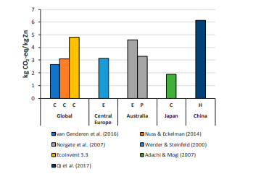

Figure 7 shows carbon footprint of global Zinc production (Nilsson et al. (2017))

Nickel as a transition metal was described by Wei et al. (2020) in terms of energy consumption and carbon emission during its production; it was concluded that the energy consumption of Nickel and its environmental impact is dependent on its ore grade and a relatively low ore grade uses more energy and emits about 8.6 tCO2-eq. Pure Nickel was also said to have a carbon footprint between 13 tCO2-eq to 26 tCO2-eq during its production. Similarly, another report presented by the Nickel institute (2020) states that every 1kg of Nickel extracted produces 13 kilograms of carbon into the atmosphere. However, they mentioned that other emissions from using sulphur chemicals to process the Nickel ore occurs.

In a discussion about the life cycle assessment of cobalt, Farjana et al. (2019) focused on cobalt extraction, processing and impact on the environment; it was presented that cobalt as a highly demanded metal in industrial production has led to the increase in cobalt mining in recent years. Correspondingly, cobalt is extracted using different methods depending on the grade and closeness to the surface; two types of cobalt mining were discussed, which are open-pit and underground while the extraction process involved pyrometallurgy, hydrometallurgy and vapour-metallurgy. Additionally, with the use of the SimaPro software and adopting the International Reference Life Cycle Data System (ILCD) together with the Cumulative Energy Demand method (CED), it was, therefore, accounted that for every 1kg of cobalt produced, about 11.73 kg Co2 eq. is emitted and this is also as a result of high use of coal fossil fuel in generating the electricity required for cobalt extraction, it was also mentioned that the Democratic Republic of Congo is the highest miner of cobalt in the world while the highest refiner is China.

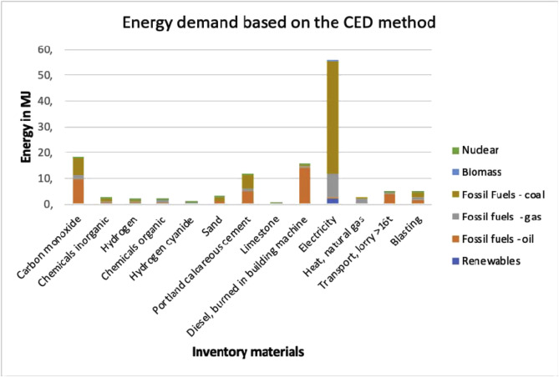

#### Figure 8 shows energy required in extracting Cobalt in Cumulative energy demand. (Farjana et al, 2019)

Silicon is the second most abundant mineral on earth. The primary driver of solar energy, Saevarsdottir et al. (2021) gave out an emission statistic for silicon extraction, Silicon which is produced from the raw material quartz and coke, given that for every tonne of Metallurgical grade silicon produced, about 10.2-12.6 metric tonnes of CO2 is emitted which is mainly as a result of energy source used for production. Also, it was established that silicon is usually produced through a carbothermic reaction in the furnace. Some of the raw materials which drive this reaction are high CO2 emitting, such as coal, woodchip, charcoal and coke.

3.2.2 GREENHOUSE GAS EMISSIONS IN NIGERIA

In the views of Daisy Dunne (2020) on the carbon emissions profile of Nigeria, Nigeria takes 17th place among the world’s greenhouse gas emitters, primarily but not singularly due to its oil resources and successful oil and gas exportation since 1965. She also mentioned that Nigeria faces energy crises leading to its epileptic power supply to the people; many people use fossil fuels for carrying out essential daily activities.

Moreover, a study by Ezeokoro et al. (2020) estimated Nigeria’s CO2 and CH4 emissions since 1965 to 2020 to be about 1.86 billion tonnes and 330 million tonnes, respectively, which is due to daily gas flaring in the Niger Delta oil-producing region. They further mentioned the visible negative changes that these emissions, such as changes in climatic conditions, environmental disasters such as flooding, poor agricultural output and diseases outbreak, have impacted. Berry et al. (2013) described gas flaring as releasing toxic gases such as carbon dioxide, Nitrate gas, sulphuric gas etc., into the atmosphere and causing atmospheric pollution.

Unsurprisingly, the oil and gas sector is not the only contributor to GHG emissions; agriculture, deforestation, general land use, and industrialisation constitute Nigeria’s greenhouse gas emissions (Uduu, 2022).

Combating climate change and cutting emissions is a common topic for everyone worldwide, and Nigeria is not left behind; just at the recent COP24 in Glasgow, Nigeria pledged under the Paris agreement to do everything possible to attain net-zero emissions by 2060 (Federal Ministry of Environment Nigeria, 2021).

3.2.3 SOLID MINERAL DISCOVERY IN NIGERIA

According to Idowu (2013), the large concentration of a mineral or group of minerals is often searched using the various range of survey methods available depending on the type of mineral being sourced and then mined in a process called mineral exploration; these minerals are very valuable and often used in industries for technological production or exchanged in the market for its monetary value. He expatiated further and specifically on the history of mining in Nigeria which began in 1903 with minerals like tin, gold and base metal; by 1940, six years before the first mining legislation was passed, tin, coal and columbite became largely produced in Nigeria than anywhere else in the world although, he also stated that as of 2013, Nigeria mining industry constituted 0.3% of its GDP because of the significant concentration on oil and gas and extremely undeveloped mining industry.

Barbour et al. (1982), as cited in Chinago et al. (2015), categorised the minerals found in Nigeria into four major groups: fossil fuel, radioactive, metallic and non-metallic minerals. Chinago et al. (2015) reported some of the minerals discovered in different parts of Nigeria, such as Coal which is about 600 million metric tonnes spread across nearly 13 states; Lead and zinc are found in abundance within the Benue trough. About 230 tonnes are produced yearly; Tin ore is majorly found in Jos Plateau in association with minerals like columbite, tantalite, Woltraxmite and molybdenite; copper is often found in association with the lead and zinc vein; iron ore is produced in tonnes at Itapke, Kogi state, gold is usually located at the basement complex region of the country, Manganese was also discovered at Oban hill. Various non-metallic minerals such as limestone, marble and glass sand are all found in Nigeria.

3.3 DATA ANALYSIS

The table below shows the value of CO2 in (Kg CO2 Eq.) emitted during mining for every tonne of each metal mentioned in the literature review.

|  |  |
| --- | --- |
| METALS (TONNE) | CARBON EMISSIONS (Kg CO2 Eq.) |
| COPPER(Desai, 2021) | 2,500 |
| LITHIUM(Crawford,2022) | 15,000 |
| ZINC(Genderen et al. 2016) | 780 |
| NICKEL(Nickel institute, 2020) | 13,000 |
| COBALT(Farjana et al., 2019) | 11,730 |
| SILICON(Saevarsdottir et al., 2021) | 10.200 |

#### Table 1 shows the different minerals required for green energy transitions and the amount of CO2 emitted during their mining extraction phase.

The table above shows the environmental impact when every tonne of each mineral, copper, lithium, zinc, nickel, cobalt and silicon, is extracted during the mining stage. As can be seen, Lithium emits the most, followed by Nickel and then cobalt which is the third highest.

The table above has also been illustrated in a graph as seen in figure 9 below:

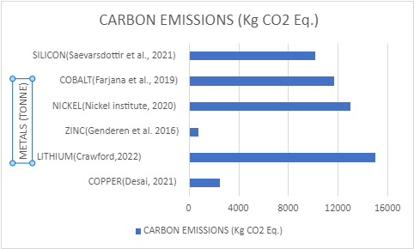

#### Figure 9 shows the graph of Carbon emissions released during the mining of various green minerals.

#### 

3.4 KEY FINDINGS

According to the authors whose works were reviewed above, it can be seen and proved that mineral extraction is one of the contributors to the climate change issues we are facing worldwide; the authors have proven and shown us the equivalent of CO2 that is emitted during the mining of some of the essential minerals that we require to aid the movement to cleaner energy. Viewing the results above, Lithium seems to have a higher emission rate which the author proved to be due to the use of fossil fuels used in generating the electricity required for mining; many of the authors whose works were reviewed above also mentioned a similar reason which is another proof of how fossil fuels are both a blessing and a curse to humanity. Cobalt, nickel, zinc, copper, silicon and lithium have all shown different carbon emission levels per every 1000kg of the mineral mined, as shown in the graph above.

3.5 POTENTIAL CARBON EMISSIONS IN NIGERIA

According to Azubuike et al. (2022), due to the plunge in oil prices between 2018 and 2019, Nigeria’s economy is forced to adopt the mineral resources corridor method in other to diversify its economy and sustain its people by tapping into her solid minerals, also as cited in the paper, olade (2019) mentioned some of the minerals such as tin, lead & zinc, copper, lithium, gold, baryte, bitumen, coal, iron ore etc., that Nigeria is blessed with. However, this is just one of the many reasons that pose potential future pressure on the mineral resources of Nigeria; another reason is the signing of the Paris agreement at the COP26; this means the Nigerian economy has joined the race to meet Net zero by 2050 and will now have to follow the long-term low emissions development strategies (Department of Climate Change, Federal Ministry of Environment, Nigeria, 2021).

Consequently, due to a glaring increase in future demand from mines and the analysis of emissions being generated at different mineral extraction sites above, there is a predicted increase in emissions from mining in Nigeria if a cleaner energy solution is not introduced into the mining sector.

Chapter four

4.1 recommendation

As stated by IEA,2021, minerals are one of the essential tools required to meet a net zero economy, however not all minerals are important in the race, and some of the crucial minerals are copper, zinc, cobalt, and lithium etc., which abundance of them have been discovered in Nigeria, my internship is part of the ongoing search to rediscover the extent of these minerals. The presence of these uncommon minerals and all the reasons stated above show a pointer to future emissions in Nigeria due to more intensive mining activities in the quest to extract these minerals. Nigeria and other countries need these minerals to build a carbon-free economy and restore damages that have been done by climate change; therefore, there is a high chance of tonnes of CO2 emissions from future mining activities in Nigeria due to the discovery of these minerals within the Nigeria Geology.

I do recommend that the Nigeria economy do investigate how to sustainably extract minerals without causing further damage to the environment; according to Dike et al. (2020), carbon capturing and storage is an effective method in removing excess CO2 in the environment, but Nigeria doesn’t have any projects on this yet. Therefore, there is a need to consider if this method is a suitable fit for Nigeria’s Geology and can be used at mines if no other better options are available.

Also, the use of solar panels in generating electricity is now a big topic in the Nigerian economy. Actions have been taken since the last COP26 to disseminate solar panels to federal offices. I would recommend the use of solar power in mines to power mining activities which is also a lot cheaper than the use of fossil fuel; according to Igogo et al. (2020), mining is very energy intensive and has the tendency to grow in the future due to increasing population and the new for raw materials in industrial activities, the integration of renewable energy in mining activities was introduced and concluded to be the best option for clean energy to be used for mining. However, modifications can be made to solar power to meet up with the intensity of mining operations.

4.2 limitations

The only limitation to this prediction is the need for extensive research focused on the subject matter and providing a solution to effectively and sustainably mine our natural resources without causing further damage to the environment. There is also a lack of adequate data telling us the extent of the minerals resource in Nigeria, which is one piece of information my internship aims to provide. However, there is still ongoing work as of the time of this report.

Chapter five

5.1 conclusions

Mining, a part of the energy sector, is currently influenced by the energy transition plans countries have pledged to under the Paris agreement. According to Henderson et al. (2021), electrification of the economy using renewable sources is the fundamental driver of energy transitioning. However, certain minerals are responsible for the start of renewables, which is why Gielen,2021 gave us an insight into critical minerals which are required, such as copper, Neodymium, dysprosium, lithium, cobalt, nickel, silver for making PV, iron, zinc, chromium, vanadium, etc., he also mentioned how these minerals would substantially increase in demand.

The internship program I undertook through the pagoda projects with my host company Xcalibur Multiphysics was very enlightening and educative as I was able to practically utilize what I have been taught in the class and have a first-hand experience of data exploration in the mineral sector. The data compilation stage in NIgeria goes further to proof how vital data gathering is in any research, it gives an insight to what has been previously done and what area should be the main point of focus.

My critical thinking ability was also improved as I had to do a lot of literature review on the study area, which helped me to put together this report. Additionally, the software training I did has set a pace for me in the job market and made me discover my weaknesses. Furthermore, I had the opportunity to meet with stakeholders in the field and discuss the future sustainability issues in mining with them.

Finally, this report has been able to explain in detail my experience as an intern with Xcalibur Multiphysics and able to predict CO2 emission from potential future mining in Nigeria.

REFERENCE

1. Azadi, M., Northey, S.A., Ali, S.H., 2020, Transparency on greenhouse gas emissions from mining to enable climate change mitigation, Nat. Geosci., Vol. 13, pp. 100–104, https://doi.org/10.1038/s41561-020-0531-3
2. Berry, P., Ogawa-Onishi, Y., McVey, A., 2013, The vulnerability of threatened species: adaptive capability and adaptation opportunity, Biology, Vol 2, pp. 872–893, https://doi.org/10.3390/biology2030872
3. Briney, A., 2021, An Overview of Spain, ThoughtCo, thoughtco.com/geography-of-spain-1435527, (accessed 30th August 2022)
4. Britannica, T. Editors of Encyclopaedia, 2022, graphite, Encyclopedia Britannica, https://www.britannica.com/science/graphite-carbon (Accessed 8th November 2020)
5. Calleja-Agius, J., England, K., Calleja, N., 2021, The effect of global warming on mortality, Early Human Development, Vol 155, pp. 0378-3782, https://doi.org/10.1016/j.earlhumdev.2020.105222.
6. Cianconi P., Betrò S., Janiri L., 2020, The Impact of Climate Change on Mental Health: A Systematic Descriptive Review, Frontier, Psychiatry, Vol 11, pp. 74, doi: 10.3389/fpsyt.2020.00074
7. Chinago, A.B., Clinton, A., Enefola, F., 2015, Geographical Survey of Nigerian Mineral Resources: A Step toward Planned Development, Journal of Culture, Society and Development, Vol 6, pp. 38-43.
8. Cornwell, J., D., Kimbell, S., F., Evans, A., D., and Cooper, D., C., 1995, A review of detailed airborne geophysical surveys in Great Britain, mineral reconnaissance programme report, British geological survey, Nottingham.
9. Crawford, I., 2022, How much CO2 is emitted by manufacturing batteries?, Environmental solutions initiatives, https://meche.mit.edu/news-media/how-much-co2-emitted-manufacturing-batteries (accessed 23rd October 2022)
10. Dunne, D., 2020, The carbon profile; Nigeria, Carbon Brief clear on climate, https://www.carbonbrief.org/the-carbon-brief-profile-nigeria/ (accessed 12th October, 2021)
11. Department of Climate Change, Federal Ministry of Environment, Nigeria, 2021, 2050 Long-Term Vision for Nigeria (LTV-2050) -Towards the Development of Nigeria’s Long-Term Low Emissions Development Strategy (LT-LEDS), Department of Climate Change, Federal Ministry of Environment, Nigeria, https://unfccc.int/sites/default/files/resource/Nigeria_LTS1.pdf (Accessed 12th November 2022)
12. Dike, S., Akani, N., 2020, Promoting Carbon, the Capture, Storage and Utilization (CCSU) in Nigeria: Lessons From the UK, Journal of International Law and Jurisprudence, Vol 6(2), pp. 184-192, https://ssrn.com/abstract=3767646
13. Ezeokoro C., Leton, T., Momoh, Y., 2021, Nigeria’s Greenhouse Gas Emissions: Estimations Based on the 5th Assessment Report, International Journal of Environment and Climate Change, Vol 11(9), pp. 52-59, ISSN: 2581-8627
14. Farjana, S., Huda, N., Mahmud, M., 2019, Life cycle assessment of cobalt extraction process, Journal of Sustainable Mining, Vol. 18 (3), pp. 150-161, ISSN 2300-3960, https://doi.org/10.1016/j.jsm.2019.03.002.
15. Gayawan, E., Arogundade, E., Adebayo, B., 2014, Possible determinants and spatial patterns of anaemia among young children in Nigeria: a Bayesian semi-parametric modelling, international health, Vol 6(1), pp. 35-45
16. Genderen, E., Wildnauer, M., Santero, N., 2016, A global life cycle assessment for primary zinc production. Int J Life Cycle Assess, Vol. 21, pp. 1580–1593, https://doi.org/10.1007/s11367-016-1131-8
17. Gielen, D., 2021, Critical minerals for the energy transition, International Renewable Energy Agency, Abu Dhabi.
18. Henderson, J., 2021, The Energy Transition: Key challenges for incumbent and new players in the global energy system, Oxford Institute for Energy Studies.
19. Idowu, o., 2013, Mineral prospecting and exploration ( with special reference to Nigeria), https://www.academia.edu/14144845/MINERAL_PROSPECTING_AND_EXPLORATION_IN_NIGERIA (accessed 18th November, 2021)
20. IEA, 2021, The Role of Critical Minerals in Clean Energy Transitions, IEA, Paris https://www.iea.org/reports/the-role-of-critical-minerals-in-clean-energy-transitions (acessed 24th September 2022)
21. Igogo, T., Awuah-Offei, K., Newman, A., Lowder, T., Engel-Cox, J., 2021, Integrating renewable energy into mining operations: Opportunities, challenges, and enabling approaches, Applied Energy, Vol. 300(3), pp. 117375, 10.1016/j.apenergy.2021.117375.
22. Nilsson, E., Aragonés, M., Torralvo, F., Dunon, V., Angel, H., Komnitsas, K., Willquist, K., 2017, A Review of the Carbon Footprint of Cu and Zn Production from Primary and Secondary Sources, Minerals, Vol. 7, pp. 168, 10.3390/min7090168.
23. Ramdhani, A., Ramdhani, M., Amin, A., 2014, Writing a Literature Review Research Paper: A step-by-step approach, International Journal of Basic and Applied Science, Vol. 3, pp. 47-56
24. Rüttinger,L., and Sharma, V. (2016). Climate Change and Mining - A Foreign Policy Perspective, Report: Climate Diplomacy, adelphi, Berlin
25. Sævarsdottir, G., Kvande, H., Magnusson, T., 2021, Greenhouse Gas Emissions from Silicon Production -Development of Carbon Footprint with Changing Energy Systems, Proceedings of the 16th International Ferro-Alloys Congress (INFACON XVI) 2021, Available at SSRN: https://ssrn.com/abstract=3926088 or http://dx.doi.org/10.2139/ssrn.3926088
26. Siemon, B., Ibs-von Seht, M., Steuer, A., Deus, N., Wiederhold, H., 2020, Airborne Electromagnetic, Magnetic, and Radiometric Surveys at the German North Sea Coast Applied to Groundwater and Soil Investigations, Remote Sens, Vol. 12, pp. 1629, https://doi.org/10.3390/rs12101629
27. Thompson, L., 2010, Climate change: The evidence and options, Behav Anal, Vol 33(2), pp. 231-233 doi: 10.1007/BF03392211
28. Watari, T., Northey, S., Giurco, D., Hata, S., Yokoi, R., Nansai, K., Nakajima, K., 2022, Global copper cycles and greenhouse gas emissions in a 1.5 °C world, Resources, Conservation and Recycling, Vol. 179, pp. 106118, ISSN 0921-3449, https://doi.org/10.1016/j.resconrec.2021.106118.
29. Wei, W., Samuelsson, P., Tilliander, A., Gyllenram, R., Jönsson, PG., 2020, Energy Consumption and Greenhouse Gas Emissions of Nickel Products, Energies, Vol. 13(21), pp. 5664, https://doi.org/10.3390/en13215664
30. White, K., Darida, K., 2022, Decarbonization and the energy transition: The next supercycle, Wellington Management, https://www.wellington.com/en/insights/low-carbon-economy-transition (acessed 9th September 2022)